Jahangirnagar University

Department of Computer Science & Engineering



Course Code: CSE-402

Course Title: Computer Networking Laboratory

Submitted by:

Md. Shamim Imtiaz

Roll No. : 47

Date of Submission: 31th October, 2019

**Experiment No: 07**

**Experiment Name:** Implementation of OSPF algorithm.

**Introduction**

Open Shortest Path First (OSPF) is a routing protocol for Internet Protocol (IP) networks. It uses a link state routing (LSR) algorithm and falls into the group of interior gateway protocols (IGPs), operating within a single autonomous system (AS). OSPF is a widely used IGP in large enterprise networks.

**Objectives**

OSPF **is** developed by Internet Engineering Task Force (IETF) as one of the Interior Gateway Protocol (IGP), the protocol which aims at moving the packet within a large autonomous system or routing domain. It **is** a network layer protocol which works on the protocol number 89 and uses AD value 110.

**Connection’s**

**3 routers and 3 pc**

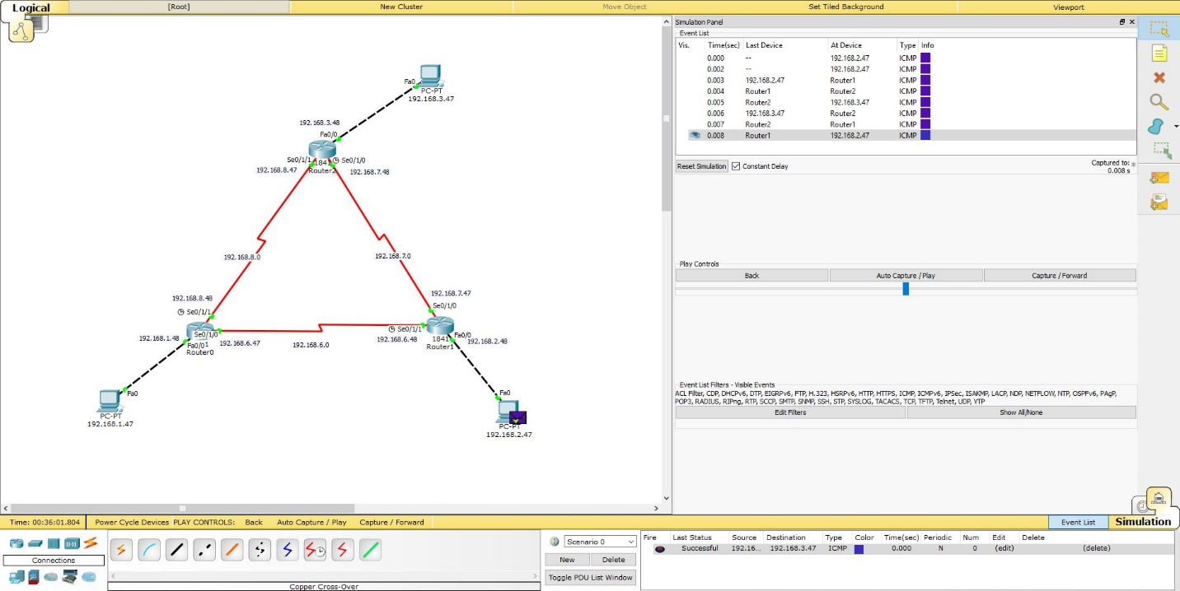

**4 routers and 3 pc**

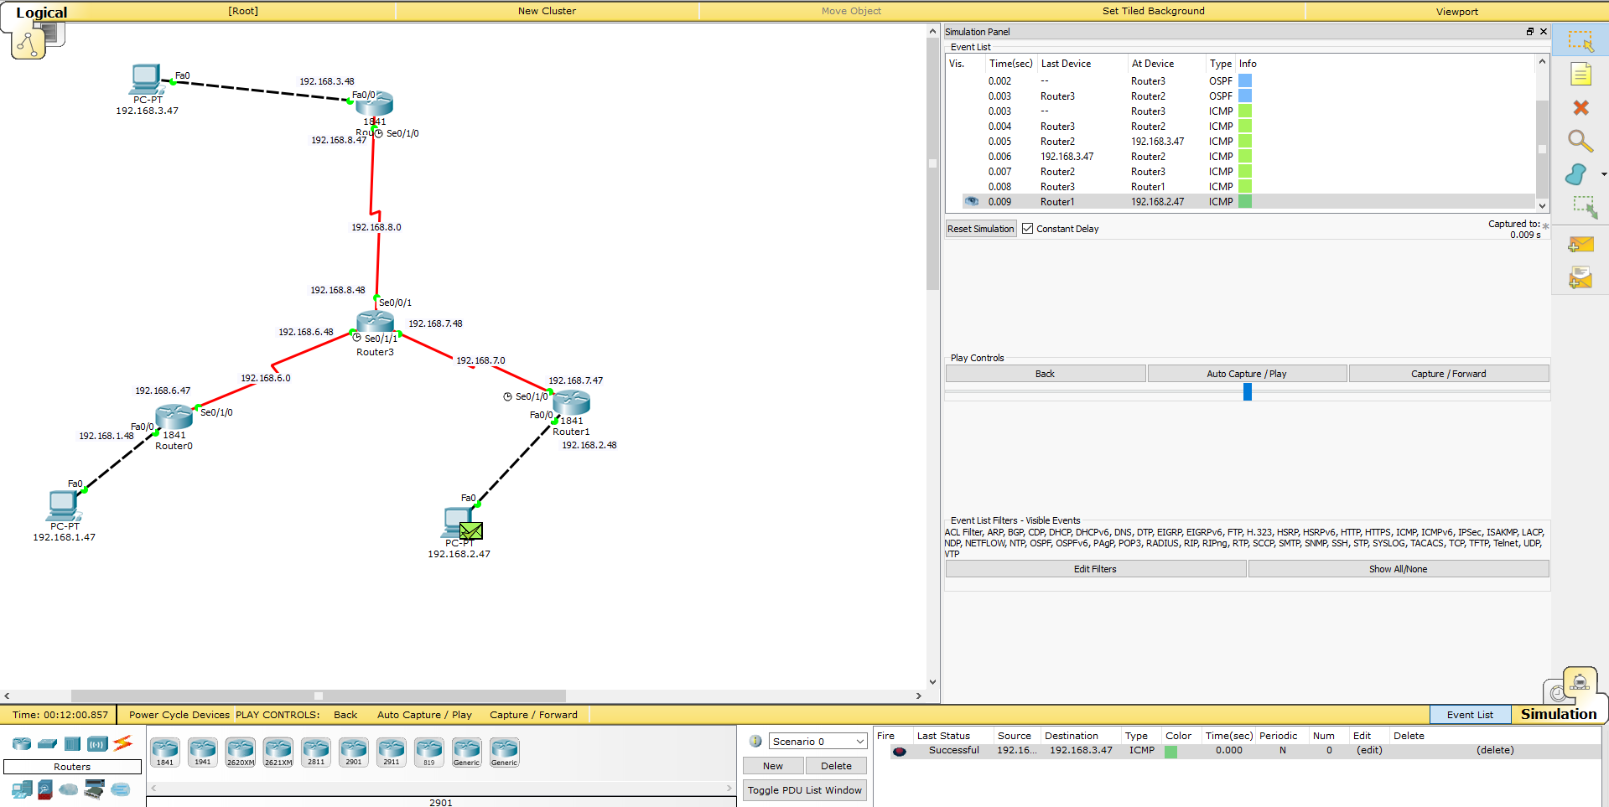

**For Router-1**

Router>en

Router#conf t

Router(config)#int fa 0/0

Router(config-if)#ip ad 192.168.1.47 255.255.255.0

Router(config-if)#no shut

Router(config-if)#exit

Router(config)# int se0/1/1

Router(config-if)#ip add 192.168.5.47 255.255.255.0

Router(config-if)#no shut

Router(config-if)#exit

Router(config-if)#exit

Router(config)#exit

Router#copy running-config startup-config

Router#conf t

Router(config)#router ospf 1

Router(config-router)#network 192.168.1.0 0.0.0.255 area 0

Router(config-router)#network 192.168.5.0 0.0.0.255 area 0

**Conclusion**

In this experiment the connections are more sensitive. So, we need to be more careful while connecting them. We need to be careful while assigning the “se” numbers, otherwise it will be difficult to complete the task. Assigning the clock is needed more attention.